
business process

E-Banking USING XXXX Web Application
UNDP, xxxX Country Office

approval DATE: _______

Template approved by the Treasurer, December 2022

 | NAME | TITLE | DATE
Author: | Treasury
Review/Update:
Review/Update:
Review:
Approved by : |  | Resident Representative

CONTENTS

1. OVERVIEW 4
2. business process 5
2.1 Summary 5
2.2 Flowchart of process 6
2.3 Narrative 6
2.4 Step by Step Processes 8
3. Segregation of tasks and control 13
3.1 Segregation of Tasks 13
3.2 Control Points 14

- OVERVIEW

This e-banking solution will be used to process domestic AP, Payroll, and T&E payments as electronic payment method and considered as an alternative until a fully Host-to-Host (H2H) Straight Through Process (STP) is implemented. This solution is implemented in accordance with the Treasury policy on Establishment and Use of Electronic Banking Systems. All the users of this solution is familiarized with this policy.
This document details the business process for using the e-banking platform using bank’s web platform/online system [specify the name of the e-banking solution] facility of {(Bank Name} for the purpose of transmitting pre-approved UFF payment file downloaded from UNDP ERP, for UNDP and Quantum agencies in {Country} by UNDP CO in [Country].
{Provide brief description of the bank’s solution being used}
The [Name of the e-banking solution] is a secured web-based e-banking platform providing domestic payment capabilities. The application provides facilities for uploading pre-formatted payment instructions and then allow authorized officers to release these payments online.
{Provide brief description of the banking relationship and technical capacity of the bank. This section should describe, at least, the agreement framework entered between UNDP and the bank, and how the e-banking solution is governed by the agreement}
Given the need to make payment in local currency in {Country} and in order to maintain proper control and ensure efficiency in operations, the CO with the support of HQ Treasury is implementing the e-banking solution provided by {Bank Name} for its operations in {Country}.

- business process

2.1 Summary

Items | Description
System | Quantum Finance, T&E, Quantum HCM for Payroll and {name of the e-banking solution}
Information providers
Input | Quantum Generated ‘UFF’ files.
Deliverables / Output | Pre-approved UFF file generated in and extracted from Quantum are uploaded in {name of the e-banking solution} and then sent electronically to bank.
Customers / users of output | Banks – domestic banks
Roles | - Downloading UFF File (for AP, GP, T&E) from Quantum after running Payment Process Request (PPR) in Quantum or receiving from the Payroll team  - Uploading UFF file into {name of the e-banking solution}  - Reviewing uploaded information and instructions against UFF  - Approving Uploaded instructions  - Releasing Payments
Reference documents | UNDP policy on:  Establishment and Use of Electronic Banking Systems; Electronic Funds Transfer Standards
Key considerations | Security of UFF file for no tampering once payment is finalized in Quantum and before and after being uploaded in {name of the e-banking solution}  {name of the e-banking solution} will be used only for the purpose of transmitting payment file once completed and generated from Quantum. No modification or new payment instruction or any other instruction of financial liability will be created solely from the {name of the e-banking solution}. The process must be rerun should a modification or new instruction be required.

  - Flowchart of process
(Figure above provided as a sample, to be adapted to the bank’s solution)

2.3 Narrative

Payment process
- Supplier and/or Staff information are entered and approved in Quantum.
- Payment requests are entered in Quantum and approved by the respective approvers in CO/GSSC/GPS. Once approved the PPR for Country Office is run by Finance/Treasury Associate (or by GSSC if clustered) to process the payments.{Specify here who runs the PPR Payroll file is finalized by GPS/PFU and shared with the respective CO focal point or GSSC for clustered offices.
- Payment instructions are downloaded in the form of ‘Universal Flat File’ (UFF) format from Quantum, protected and saved on a secured computer. {Specify here who completes this process}. For clustered CO where GSSC is running the PPR, GSSC will download and save the UFF file and the link and password to the ONE DRIVE is sent to authorised CO finance unit staff for CO to download the secured file for further processing. Payroll file received from GPS/PFU is uploaded on that same location by CO focal point or GSSC for clustered offices. Only limited and authorized staff have access to this computer.
Note: Reference to AP UFF file throughout this document refers to the output file for T&E payments.
{For the purpose of data security, please arrange and specify the secured location where the UFF file will be saved and access to this will be limited to only authorized staff.}

Uploading in {name of the e-banking solution}

- Finance Assistant/Associate/GSSC (where access to bank’s online portal is provided to GSSC) logs in the web based {name of the e-banking solution}using combination of dynamic generated password/token provided by the bank and PIN assigned to s/m and upload the UFF file.
- Finance Asst/Associate/GSSC cross checks and compares data on {name of the e-banking solution} with the finalized UFF data. If the data does not match at this stage, the payment will be rejected.
- Finance Asst/Associate confirms the data match and sends for further approval by the Disbursing officer for next stage of approval.
Note: UFF AP/GP files should be secured either using encryption or any other secured tool to protect the file from unwanted tampering. Where possible, option should be explored to send or upload the encrypted file on the bank’s platform and have the bank unencrypt the file. Under this method, the encryption keys are shared with the bank .

Releasing/Approving payments

- The Operations Manager(OM) or DRR/Disbursing officer {specify who is the approving officer.} securely logs into the {name of the e-banking solution} to review and confirms the data match with finalized UFF and approves/releases the payment.
- The second approving officer/The RR or Senior Manager acts as the second person to release the payment after necessary verification of authenticity of authorized payment. {In some cases, two approving officers can be assigned, if so, specify the role of each approving officer otherwise remove this section.}

Verification of payment status

- CO Finance Assistant/Associate downloads the approved file from {name of the e-banking solution} and saves in a secured location.
- The Finance Assistant/Associate in CO check status of payment online in {name of the e-banking solution}
2.4 Step by Step Processes

Downloading UFF File for AP and T&E Payments

After the PPR process is completed, the user needs to go to the Schedule Request and under Process Name look for Fomat Payment File.  Then click on the view output link  Click on the hyperlink highlighted to download the UFF payment file | 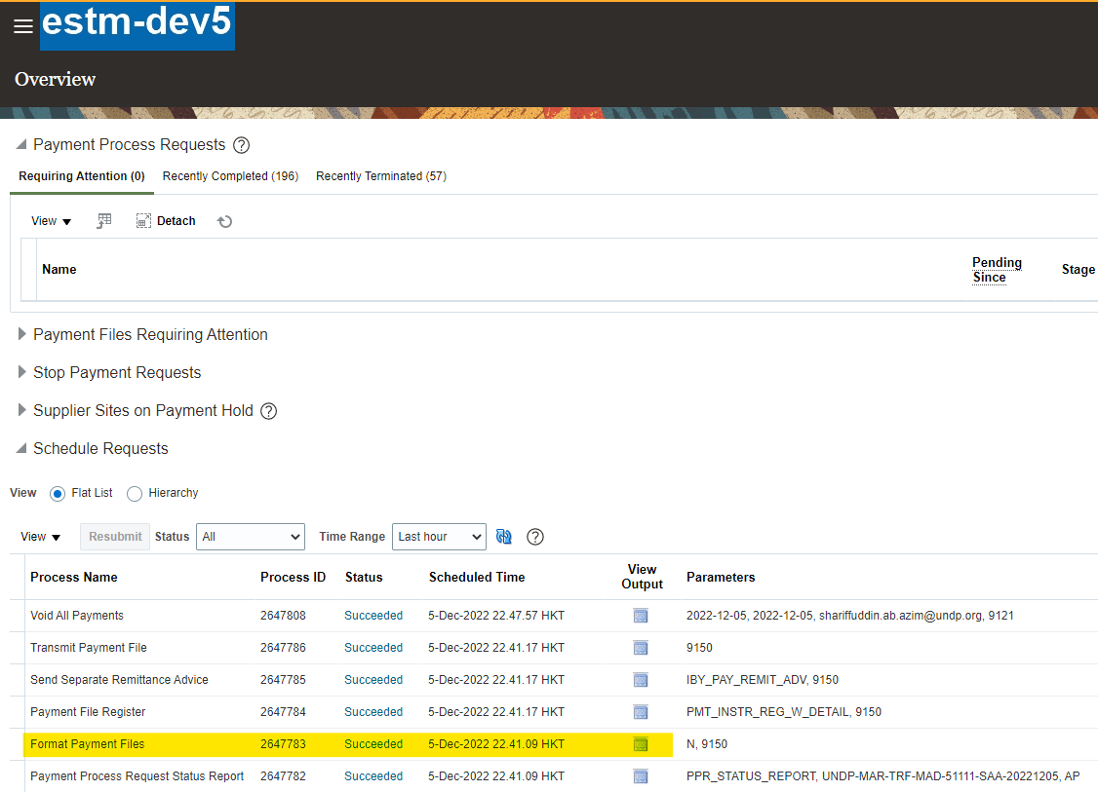  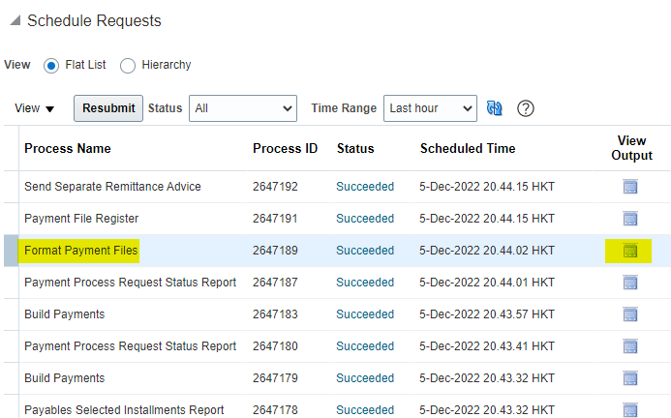  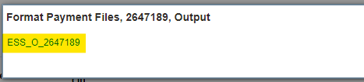

Save the downloaded file in the respective CO’s sharefolders. | 

2.4.2 Receiving UFF file for Payroll
The GPS/PFU team runs the process to calculate and finalize the banking UFF file for payroll in Quantum. The GPS/PFU team shares the file with CO focal point xxxxx (please specify which staff receives and handles this file in CO) using a secured UNDP email channel or allow download option similar to AP files from Quantum designated site.
(Please append here the the screen shots of the process)

2.4.3 Uploading UFF File and Releasing Payments

{name of the e-banking solution} pages to upload and release payments [screen shots provided as samples, please append the screen shot from your specific e-banking solution]

Log-in page with dynamically generated password/token/key provided by {Bank’s Name}  Uploading page, for payment file generated from Quantum  Releasing/Approving payments showing list of payments awaiting authorisation in {name of the e-banking solution}.  User to select payment and click on authorize multiple button below.  {Add another level if secondary approval is required}  Review, download and save the approved payment file. | 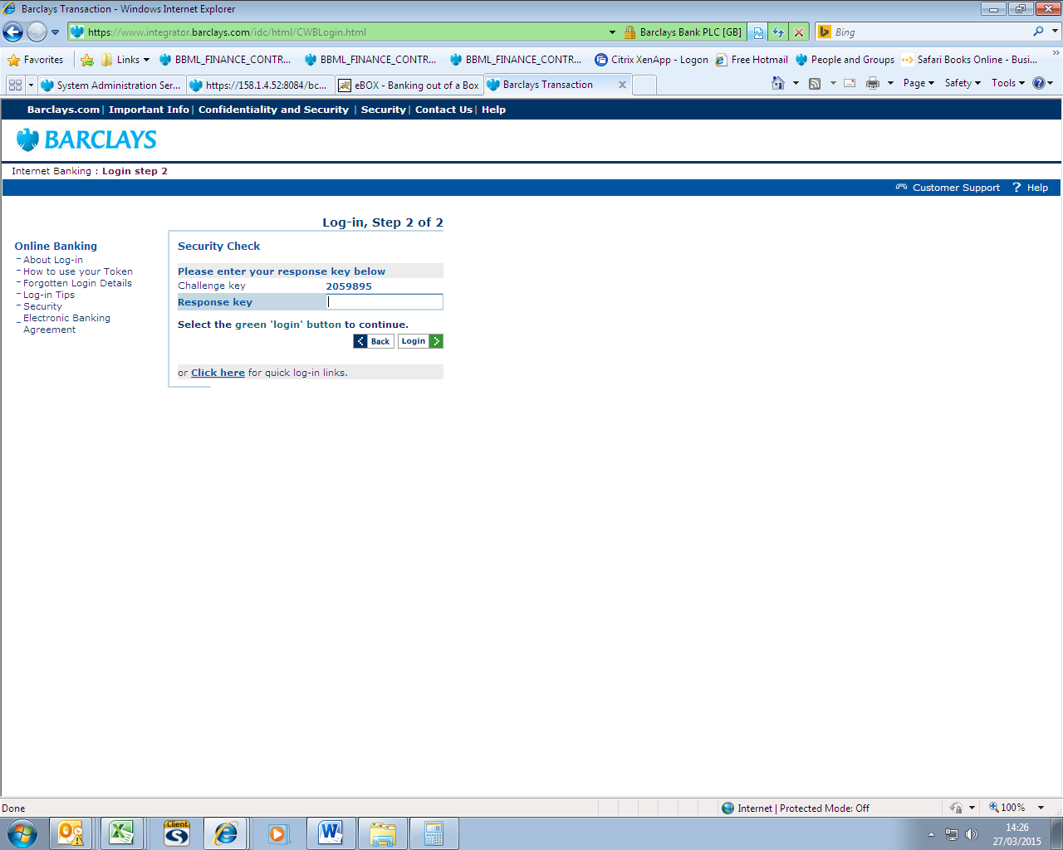  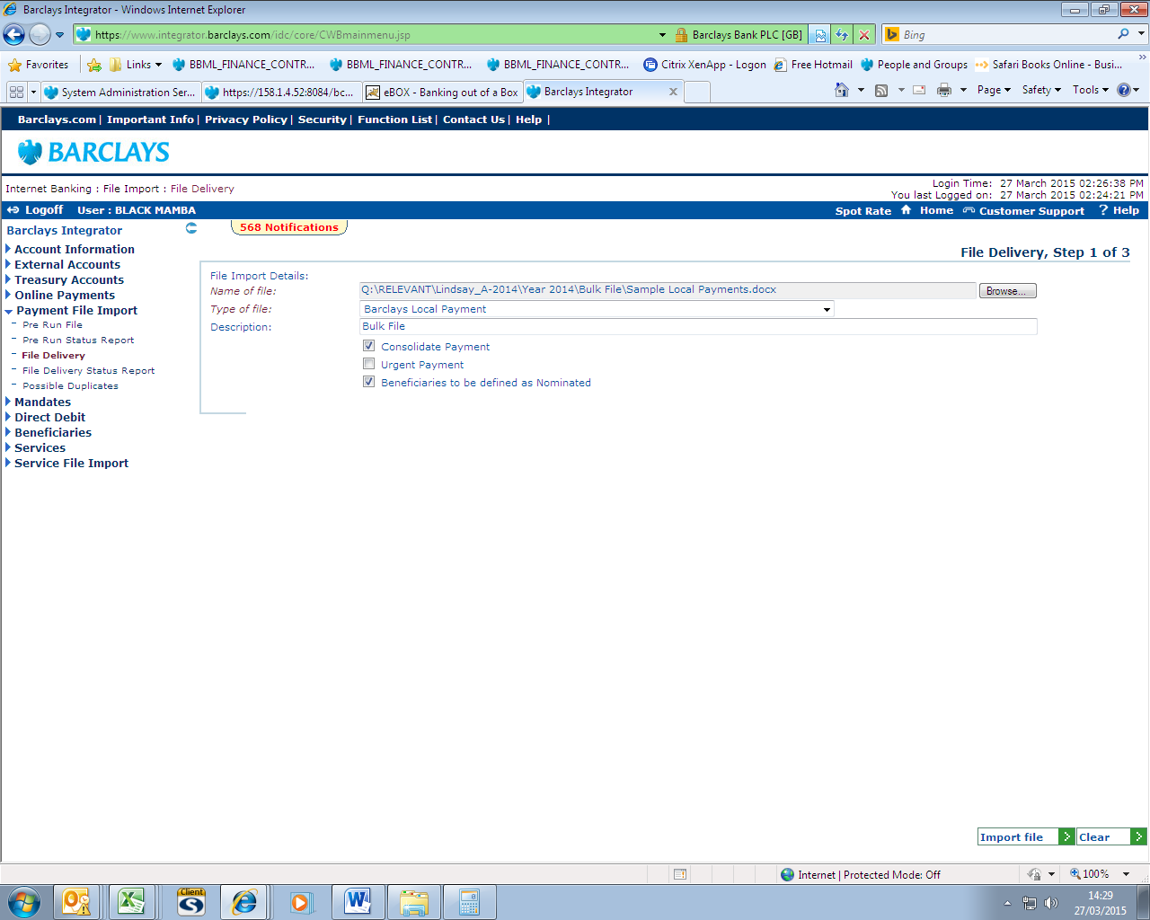  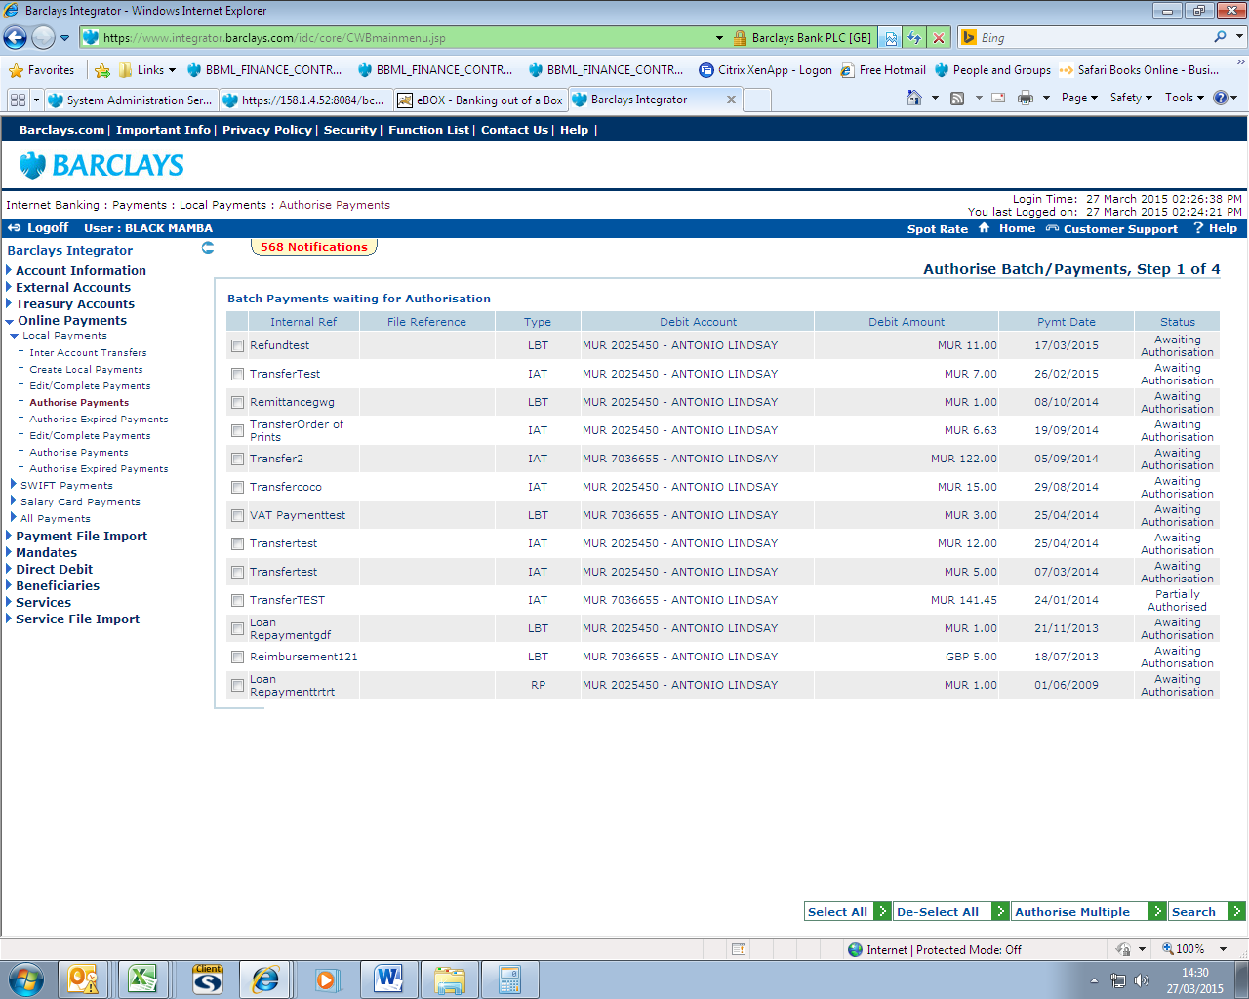  Screen shot

2.4.4 Checking Payment Status

{name of the e-banking solution} pages to check payment status

Page to check payment status.  User can check payment status by Supplier.  Payment status query by data range.  Format of Bank Statement MT940 statements (daily basis) are also available. {Please amend this section based on the kind of reports provided by the bank} | 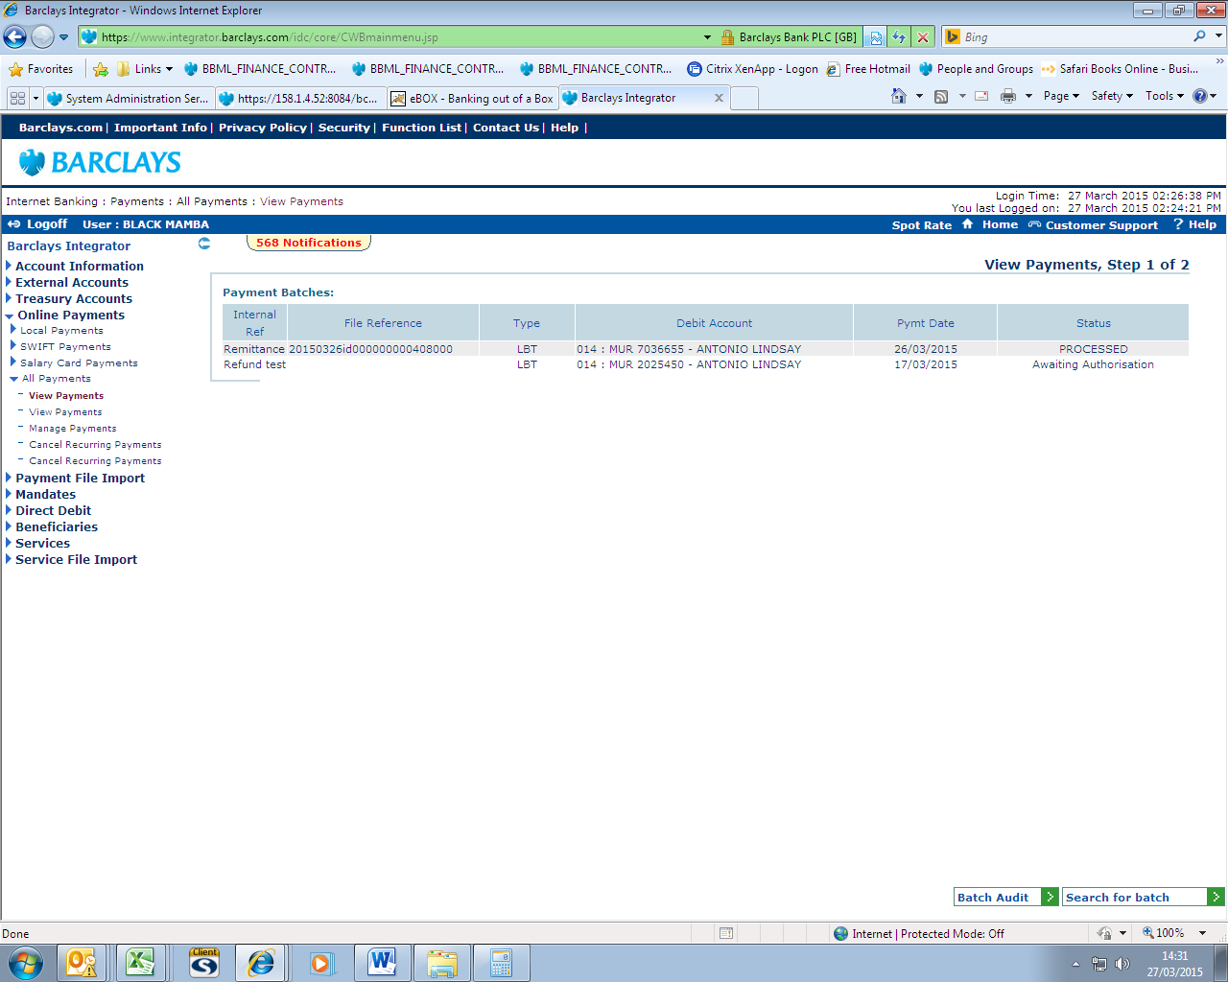  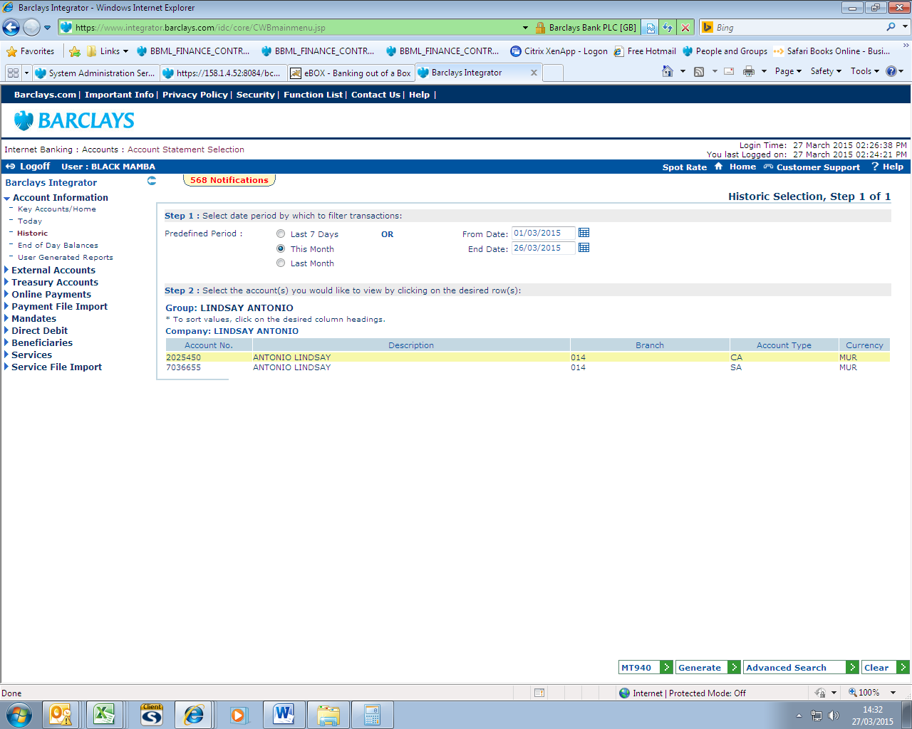

2.4.5 Data storage for future reference
UNDP finalized UFF files are protected and stored on a secured folder  Payment file approved on the bank’s platform is protected and stored on the same secured folder. | Screen shot

3. Segregation of tasks and control

The following control is put in place to ensure that payment instructions generated by Quantum in the UFF file is not be tampered with.
The UFF file is controlled at two levels with segregation of tasks

  - Segregation of Tasks

    - The Finance Assistant/Associate/GSSC downloading the file from Quantum will be {Specify the designated person performing this function}. This staff must be different from the staff that will upload the file on the {name of the e-banking solution}.
    - The Finance Assistant/Associate/GSSC (where access to bank’s online portal is provided to GSSC) uploading the file will be {Specify the designated person performing this function}. This staff must not be the same person releasing/approving the payment on the {name of the e-banking solution}.
    - The approving officer(s) will be OM/DRR/RR {Specify the designated person performing this function}. This staff should be the signer on bank account, a disbursement officer but not be the one performing bank reconciliation, nor creating AP vouchers or deposits; and where only one bank account signatory is authorized by the Treasurer, the signatory cannot also be a Supplier approver.
    - The staff performing Bank Account reconciliation should be different from staff downloading the file from Quantum and from staff uploading the file onto the bank platform.
  - Control Points

    - The Finance Assistant/Associate- checks integrity of data uploaded in {name of the e-banking solution} by comparing the final payment file with approved UFF file with more detail sampling, number of transactions and absolute amount.
    - The approving officer(s) before releasing the payment ensure that the final payment file in the {name of the e-banking solution} matches with the UFF file finalized in Quantum, number of transactions and absolute amount.
    - Bank reconciliation done by GSSC B2B Team with payment details based on the daily bank statement provided by the Bank.

